**Requirements For Claim Recovery Field**

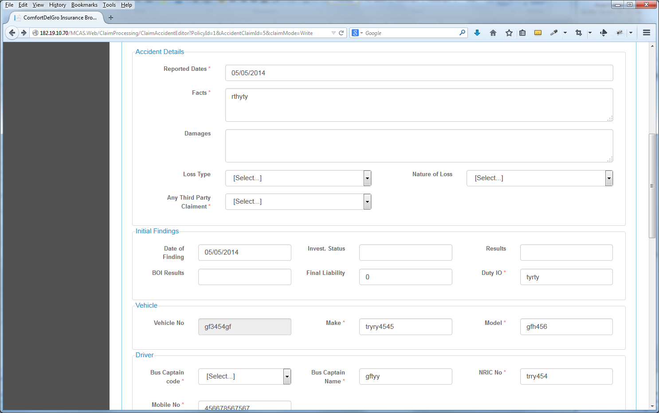

Claim Recovery: Yes/ No

**1. Add a Claim Recovery Field next to the Any Third Part Claimant Field under the Claims Tab**

**2. The Options available are Yes / No**

**3. If Yes is chosen, there will be a new Field “Add New Recovery” that will be opened up under the Claims Recovery Processing Module > Payment Tab when it is saved.**

Note that the Add New Recovery Button will only appear in Claims Recovery Processing Module > Payment Tab and not in Claims Registration > Payment Tab.

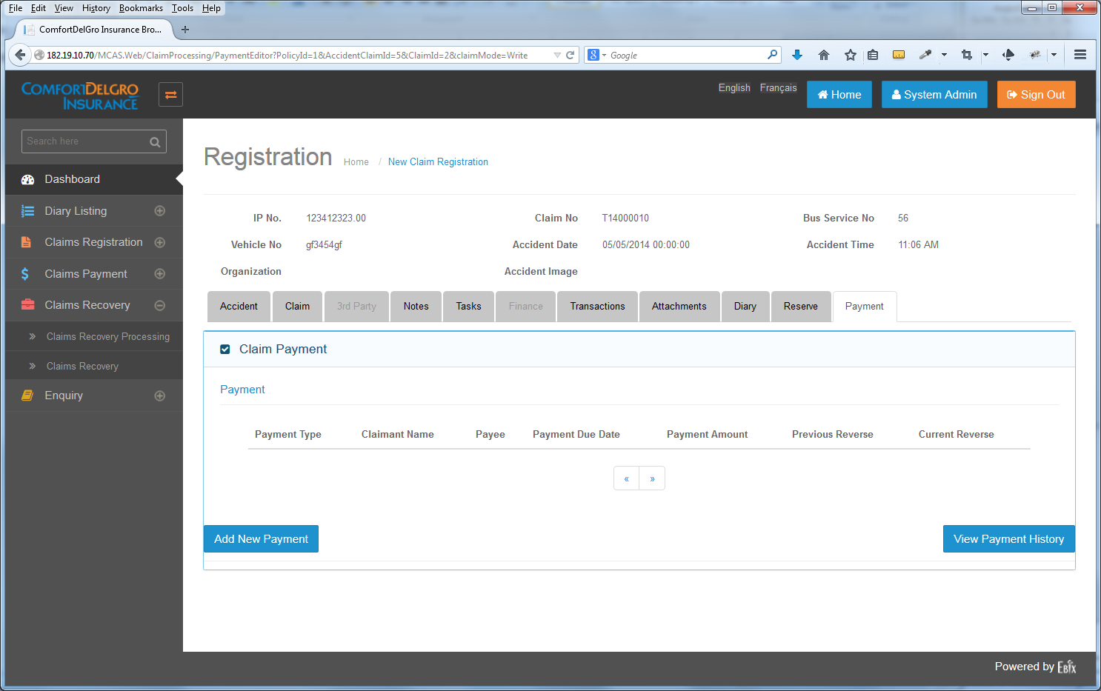

Add New Recovery

**4. At the Claims Recovery Processing > Payment Tab -- When The Add New Recovery Button is clicked:**

System will display these Fields:

Recovery From: <Name - Free Text> <Address – Free Text>

Reason For Recovery: <Free Text>

Amount: <To Show List Of Currencies, Exchange Rate, Converted To Local Currency>

Status: <Dropdown Values – Pending | Received>

Payment Details: (When Received Value is selected) <Free Text>

Save Button

Note: Only when Received value is selected, the Payment Details Field will be opened up and once the entry is saved with the inputs. The System will balance the values in the View Payment History. This Amount will be a negative value and will subtract from the list of Payment Entries.

This Entry will be changed to View Only under the Claims Recovery Processing and no more editing is allowed.

**5. Users can only come to the Claims Recovery Processing Module to search, click on the entry and update the Status value, Payment Details**

**6. The Claims Recovery Module is to be removed.**